

Dr. D. Y. Patil Unitech Society’s
Dr. D. Y. Patil Arts, Commerce and Science College, Pimpri, Pune-18

A PROJECT REPORT ON

“Employee Management System”

Developed by

Snehal Madhukar Berad

In partial fulfillment of

T.Y.B.C.A ( Science) Sem-VI
Under

Savitribai Phule Pune University 2024- 2025



Dr. D. Y. Patil Unitech Society’s
Dr. D. Y. Patil Arts, Commerce and Science College, Pimpri, Pune-18

CERTIFICATE
Exam Seat No.:750

This is to certify that Snehal Madhukar Berad(6) has successfully completed the Project Work entitled Employee Management System
for T.Y.B.C.A(Science) Sem-VI of Savitribai Phule Pune University for the Academic Year 2024-25.

Project Guide Coordinator I/C Principal & H.O.D. (C.S)

External Examiner Internal Examiner

Acknowledgement

I would like to express my sincere gratitude to all those who have contributed to the successful completion of this project. It has been my sincere effort to present the subject in a simple and clear manner, and I am truly appreciative of the guidance and support provided by everyone involved.
First and foremost, I would like to extend my heartfelt thanks to my project guide, Mrs. Pooja Patil, for their valuable guidance and constant support throughout the project. Their insights and expertise have been instrumental in the development of this work.
I am also deeply grateful to Dr. Ranjit Patil, Principal of the College, for their unwavering support and encouragement. Special thanks to Dr. Sujata Patil, Coordinator of the Department, for her continuous assistance and guidance.
Working on this project has been an incredibly enriching and enlightening experience. I have learned that "team spirit makes even the most difficult tasks easier and more enjoyable." I would like to thank my friends for their cooperation, keen interest, and valuable suggestions that contributed to the success of this project.
Once again, my heartfelt thanks to everyone who supported me in this endeavor.

INDEX

SR. No. | Content
1 | Introduction to System
2 | System Analysis  2.1 Existing System  2.2 Need of Computerization  2.3 Proposed System  2.4 Scope and Objective of Proposed System  2.5 Fact Finding Techniques  2.6 Feasibility Study
3 | Requirement Specification
4 | System Design  4.1 Entity Relationship Diagram  4.2 Data Flow Diagram  4.3 Class Diagram  4.4. Use case Diagram  4.5 Activity Diagram  4.6 Sequence Diagram  4.7 Deployment diagram  4.8 Data Dictionary
5 | System Implementation
6 | Input-Output Screen & Reports
7 | Limitations
8 | Future Enhancements
9 | Conclusion
10 | References

- Introduction to System

IT Company Employee Management System - Introduction
In today's fast-paced IT industry, efficient employee management is crucial for maintaining smooth business operations. Traditional record-keeping methods, such as paper files and spreadsheets, often lead to inefficiencies, data redundancy, and errors. To address these challenges, the IT Company Employee Management System has been developed as an automated solution for handling employee records with accuracy and efficiency.
This system is built using Core Java (Swing & AWT) for an interactive user interface and MySQL for secure and structured database management. It offers HR managers a centralized platform to manage employee details, track technical skills, generate reports, and oversee project assignments.
Key Features
- User Authentication – Ensures secure access to the system.
- Employee Management – Allows adding, updating, and deleting employee records.
- Technical Skill Tracking – Stores and manages employee skill sets.
- Report Generation – Generates workforce reports for analysis.
- Project Management – Monitors assignments and project progress.
By automating these processes, the system reduces manual workload, improves data accuracy, and enhances decision-making for IT companies. Future enhancements may include cloud-based access, payroll integration, and advanced security measures to further optimize its functionality.

- System Analysis

2.1 Existing System

Many IT companies rely on outdated manual methods or spreadsheets, causing inefficiencies and security risks. Employee records are often scattered across different files or registers, leading to duplication, outdated information, and difficulty in accessing accurate data. The lack of a centralized database makes it challenging for HR personnel to track and update employee details efficiently.

Security concerns arise due to the absence of role-based access control, making sensitive information such as salaries, job roles, and personal details vulnerable to unauthorized access or accidental modifications. Without a secure system, companies risk data breaches, compliance issues, and operational inefficiencies.

Manual processes also make workforce management time-consuming and error-prone. Searching for employee details, verifying credentials, and generating reports require extensive effort, increasing the chances of human errors. Decision-making becomes slower and less reliable due to the lack of real-time data access and automation.

Additionally, IT companies struggle with effective employee skill tracking. Assigning projects based on expertise is difficult when records are maintained manually. This results in inefficient workforce allocation, delays in project execution, and challenges in identifying suitable employees for specific tasks.

A computerized Employee Management System addresses these issues by improving data accuracy, security, and operational efficiency. It streamlines HR processes, enhances data management, and ensures proper workforce utilization, contributing to overall organizational productivity.

  - Need of Computerization

To address the inefficiencies of the manual system, an automated IT Company Employee Management System is essential. This system will streamline and secure employee data while offering better accessibility and accuracy.
Centralized data storage eliminates redundancy and ensures real-time updates by maintaining all employee records in a single MySQL database. Digital records allow for faster and more accurate processing, reducing manual workload and improving productivity. The system also enhances security by implementing user authentication, ensuring that only authorized personnel can access or modify sensitive data such as salaries and personal details.
Key Benefits of Computerization:
- Improved Efficiency: Automates routine HR tasks, reducing manual workload and increasing productivity.
- Real-Time Data Access: Ensures quick retrieval and updates of employee information.
- Enhanced Security: Protects sensitive employee details with authentication mechanisms.
- Better Employee Tracking: Helps HR teams manage job roles, technical skills, and departmental assignments effectively.
- Accurate Workforce Planning: Provides structured data to allocate resources efficiently for projects.
- Automated Report Generation: Produces department-wise, skill-based, and job-role-specific reports for informed decision-making.
By adopting a computerized system, IT companies can significantly reduce human errors, enhance security, and improve operational efficiency, leading to better workforce management and streamlined HR operations.

  - Proposed System

To overcome the limitations of the manual system, the IT Company Employee Management System is designed to automate employee management tasks efficiently.
Key Features of the Proposed System
- User Authentication and Access Control
Secure login for HR/admin personnel to prevent unauthorized access.
- Employee Record Management
Ability to add, update, delete, and view employee records.
- Technical Skill and Job Role Tracking
Maintains records of employees’ job assignments, skills, and certifications.
- Graphical User Interface (GUI)
Developed using Swing & AWT for an interactive and user-friendly experience.
- Database Management (MySQL)
Employee data will be securely stored in a structured database for easy access and management.
- Report Generation and Analysis
Generates custom reports on employees, departments, and workforce allocation.
The proposed system is designed to be efficient, secure, and scalable, enabling IT companies to manage their employees systematically and make data-driven decisions.

2.4 Scope and Objective of Proposed System

The IT Company Employee Management System is designed to overcome the inefficiencies of a manual employee management process by automating key HR and administrative tasks. This system ensures secure employee data handling, simplifies workforce management, and improves decision-making through real-time reporting and analysis.
The system will feature user authentication and access control to ensure data security, an interactive GUI (developed using Swing & AWT), and database management (using MySQL) for structured storage and retrieval of employee records. It will also support technical skill tracking, job role assignments, and workforce allocation reporting, making it a comprehensive and scalable solution for IT companies.
Objectives
The main objectives of the proposed system are:
- Automate Employee Data Management – Allow HR personnel to efficiently add, update, delete, and view employee records in a centralized system.
- Enhance Security and Access Control – Implement secure login authentication to prevent unauthorized access to sensitive employee data.
- Track Employee Skills & Job Roles – Maintain up-to-date records of employee skills, certifications, and job assignments to optimize project allocations.
- Provide a User-Friendly Interface – Develop an interactive and responsive Graphical User Interface (GUI) using Swing & AWT for smooth navigation and usability.
- Ensure Efficient Database Management – Store and manage employee data securely using MySQL, ensuring fast retrieval and scalability.
- Generate Reports for Data-Driven Decisions – Offer customized reports on employees, departments, and workforce distribution to assist in strategic decision-making.
By implementing this system, IT companies can increase efficiency, enhance security, and streamline employee management processes, making workforce handling more structured and data-driven

  - Fact Finding Techniques

To develop an efficient IT Company Employee Management System, various fact-finding techniques were employed to gather essential requirements and understand the challenges in employee management.

1. Stakeholder Interviews – Discussions with HR managers, project managers, and IT department heads helped identify key challenges such as difficulty in tracking employee roles, inefficient project management, and lack of a centralized employee data system.

2. Direct Observation – Analyzed manual HR processes like employee record maintenance, leave applications, and project assignments, revealing inefficiencies such as paper-based records, inconsistent data updates, and difficulty in monitoring employee skills and project contributions.

3. Employee Surveys & Feedback Forms – Questionnaires were distributed to employees across different departments to assess their pain points. Common issues reported include delays in leave approvals, limited access to personal records, and lack of transparency in project role assignments.

4. Review of Existing Systems & Policies – Company policies related to employee data security, project allocation, leave management, and skill tracking were examined. Existing HR or employee management software was also reviewed to identify gaps that need to be addressed in the new system.

5. Data Analysis & Process Mapping – Current HR and project management workflows were mapped to identify redundant tasks and optimize processes in the proposed system, ensuring support for real-time employee tracking, skill management, and structured project role assignments.

These techniques provided valuable insights, helping design a secure, scalable, and user-friendly employee management system that streamlines HR and project-related tasks efficiently.

  - Feasibility Study

A feasibility study was conducted to evaluate the practicality of developing and implementing the IT Company Employee Management System across key aspects:
1. Technical Feasibility
- The system will be developed using Java (Swing & AWT) for GUI and MySQL for database management, ensuring a structured and efficient approach to employee record handling.
- It will support secure authentication, allowing authorized HR personnel to manage employee records efficiently.
- The system will provide functionalities like real-time employee tracking, project role assignments, and leave management without requiring extensive hardware upgrades.
2. Operational Feasibility
- The system streamlines HR operations by automating employee data management, leave tracking, and project assignments, reducing errors and workload.
- A user-friendly graphical interface ensures ease of use for HR personnel and employees, improving overall efficiency.
- The system enables quick retrieval and updating of employee records, making HR processes more responsive and well-organized.
3. Economic Feasibility
- The system is built using open-source technologies, reducing software licensing and development costs.
- Automating manual HR tasks will save time and resources, leading to long-term cost benefits.
- The investment in the system provides a high return on investment (ROI) by enhancing productivity and minimizing administrative workload.
4. Legal Feasibility
- The system complies with data privacy and security regulations, ensuring that employee information is stored securely and protected from unauthorized access.
- It adheres to company policies regarding employee data management, leave processing, and project tracking, ensuring smooth HR operations.
5. Schedule Feasibility
- The development follows a structured timeline with defined milestones for analysis, design, implementation, testing, and deployment.
- The system is designed to be developed and deployed within a feasible timeframe, ensuring timely delivery without excessive delays.
Based on this study, the IT Company Employee Management System is technically, operationally, economically, and legally feasible, making it a practical and scalable solution for IT companies.

- Requirement Specification

Requirement Specification defines the system’s functionalities, performance expectations, and constraints. The IT Company Employee Management System streamlines employee data management, including job roles, skills, and department assignments, ensuring efficient HR operations.
Hardware & Software Requirements
1. Hardware Requirements
- Processor: AMD Ryzen 7
- RAM: 8GB (Recommended: 16GB)
- Storage: 256GB SSD (Recommended: 512GB SSD)
- Display: 1080p Full HD
2. Software Requirements
- OS: Windows 10/11
- Language: Core Java (Swing, AWT)
- Database: MySQL Server
- IDE: IntelliJ IDEA
- APIs: JDBC API, MySQL Connector JAR

Functional Requirements
1. Employee Management
- Add, update, delete, and retrieve employee records.
- Manage job roles and technical skills.
2. Department & Role Management
- Assign employees to departments and manage roles.
3. User Authentication
- Secure login for HR/Admin users.
4. Search & Filter
- Search employees by ID.
- Filter employees by job roles and skills.
5. Database Integration
- Store and retrieve employee records efficiently.

Non-Functional Requirements
- Performance: Supports 500+ employees, search results in 2 seconds.
- Security: Password-protected authentication, encrypted records.
- Usability: User-friendly GUI, minimal training required.
- Scalability: Future upgrades possible (e.g., leave tracking).

System Design

4.1 Entity Relationship Diagram

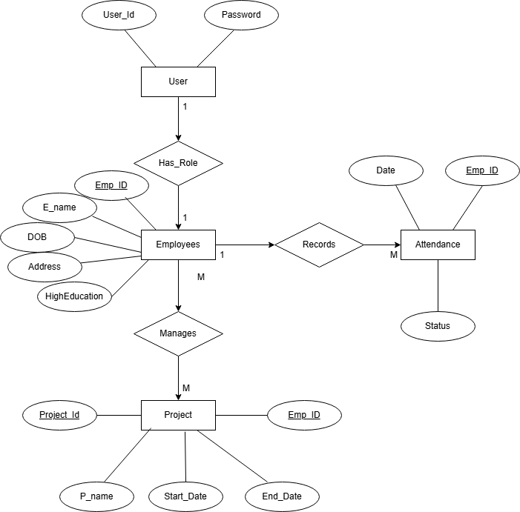
4.2 Data Flow Diagram

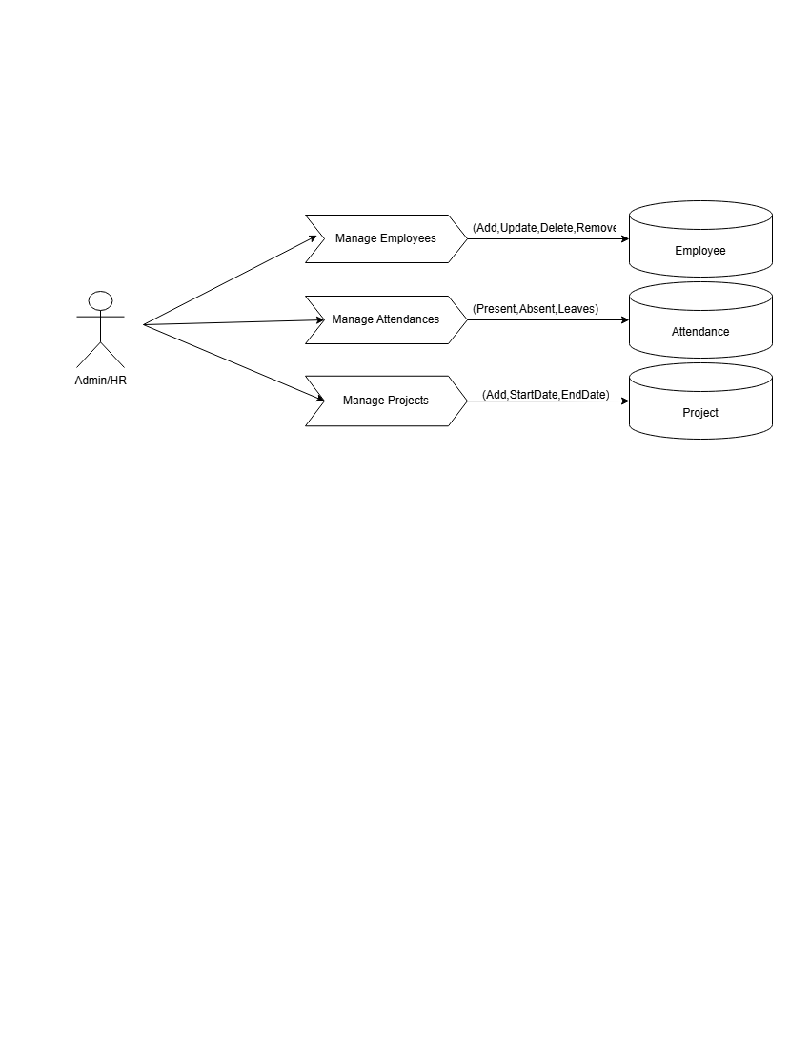

4.3 Class Diagram

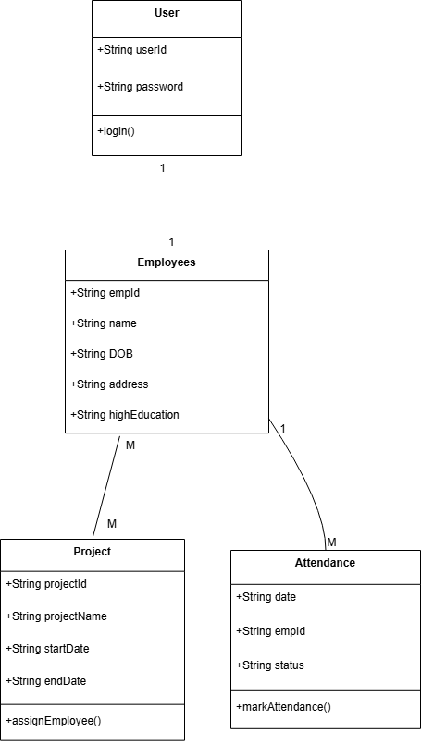

4.4. Use case Diagram

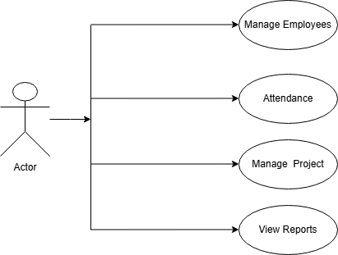

4.5 Activity Diagram

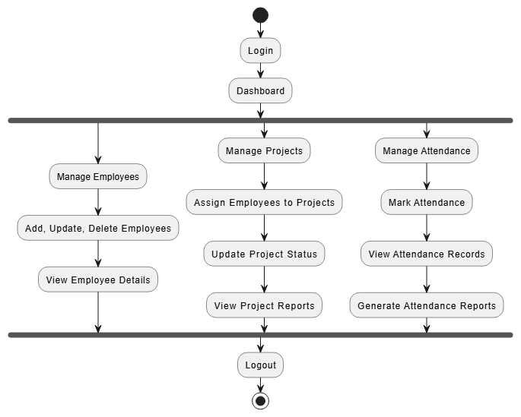

4.6 Sequence Diagram

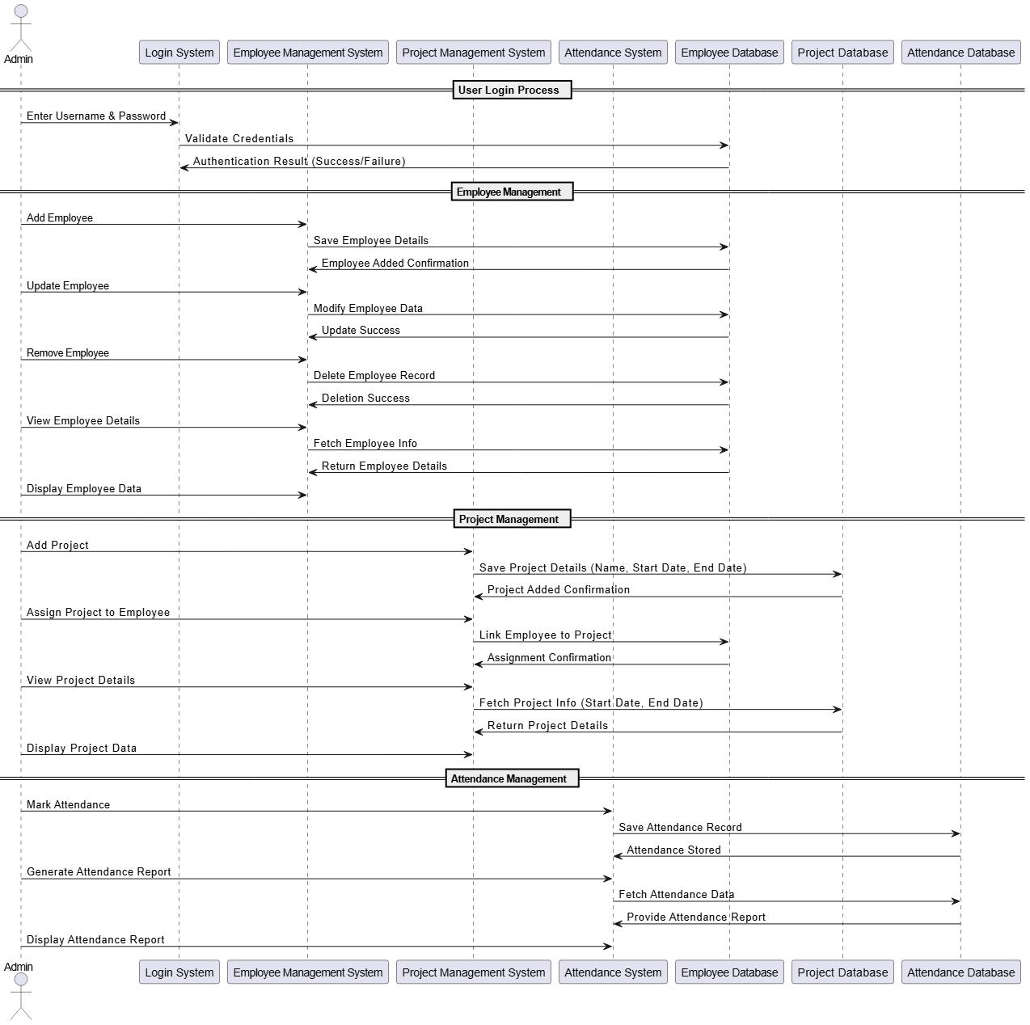

4.7 Deployment diagram

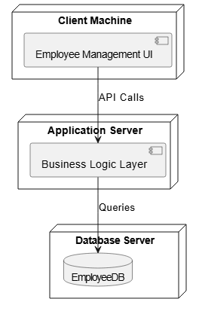
4.8 Data Dictionary

Add Employee

Name | Type | Schema
name | VARCHAR | “name” VARCHAR
fname | VARCHAR | “fname” VARCHAR
dob | VARCHAR | “Dob” VARCHAR
salary | FLOAT | “Salary” FLOAT
address | VARCHAR | “Address” VARCHAR
Aadhar | VARCHAR | “Aadhar” VARCHAR
phone | VARCHAR | “Phone” VARCHAR
email | VARCHAR | “Email” VARCHAR
education | VARCHAR | “Education” VARCHAR
designation | VARCHAR | “Designation” VARCHAR
emp_id | INT | “emp_id” INT
role | VARCHAR | “Role” VARCHAR

Mark Attendance

Name | Type | Schema
emp_id | INT | “emp_id” INT(FK)
date | DATE | “date” INT
status | DATE | “status” INT

Project

Name | Type | Schema
Assing_id | INT | “Assing_id” INT(PK)
P_id | INT | “P_id” INT (PK)
emp_id | INT | “emp_id” INT(FK)
P_name | VARCAHR | “P_name” VARCHAR
StartDate | INT | “StartDate” INT
EndDate | INT | “EnadDate” INT
Status | VARCHAR | “Status” VARCHAR

5.System Implementation

System implementation involves installing, configuring, and deploying the IT Company Employee Management System to ensure optimal functionality. The system efficiently manages employee data, including job roles, skills, and departmental assignments.
Installation & Configuration
Hardware & Software Requirements
- Hardware: AMD Ryzen 7 / Intel Core i5, 8GB RAM (16GB recommended), 256GB SSD (512GB recommended).
- Software: Windows 11, IntelliJ IDEA, Java (Swing, AWT), MySQL Server, MySQL Workbench.
Installation Steps
- Install JDK for Java application compatibility.
- Set up IntelliJ IDEA and configure project files.
- Install MySQL and create required tables.
- Integrate JDBC Driver for database connectivity.
- Compile and run the system for validation.
5.3 Database Integration & System Development
The system uses MySQL to store and manage employee records.
Database Setup
CREATE TABLE employees (
emp_id INT PRIMARY KEY AUTO_INCREMENT,
name VARCHAR(100) NOT NULL,
department VARCHAR(50),
role VARCHAR(50),
salary DECIMAL(10,2)
);
System Development
- Frontend: Java (Swing & AWT) for an interactive UI.
- Backend: Java & JDBC for business logic and database operations.
- Core Features:
  - Employee CRUD operations.
  - Secure login authentication for HR/Admin.
  - Employee search and filter functionalities.
5.4 Testing & Deployment
Testing Approach
- Unit Testing: Validates individual system modules.
- Integration Testing: Ensures seamless interaction between UI and database.
- User Acceptance Testing (UAT): HR/Admin validate system performance.
Deployment Process
- Pilot Deployment – Initial testing with selected users.
- Full Deployment – Organization-wide system implementation.
- Post-Deployment Monitoring – Ensuring smooth operation with regular updates.

6.Input-Output Screen & Reports
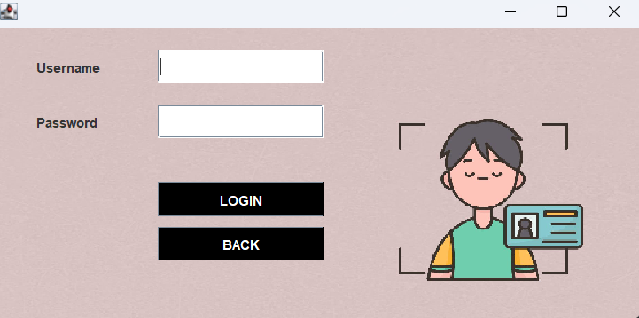
1. Login Page:-

2.Dashboard Page:-

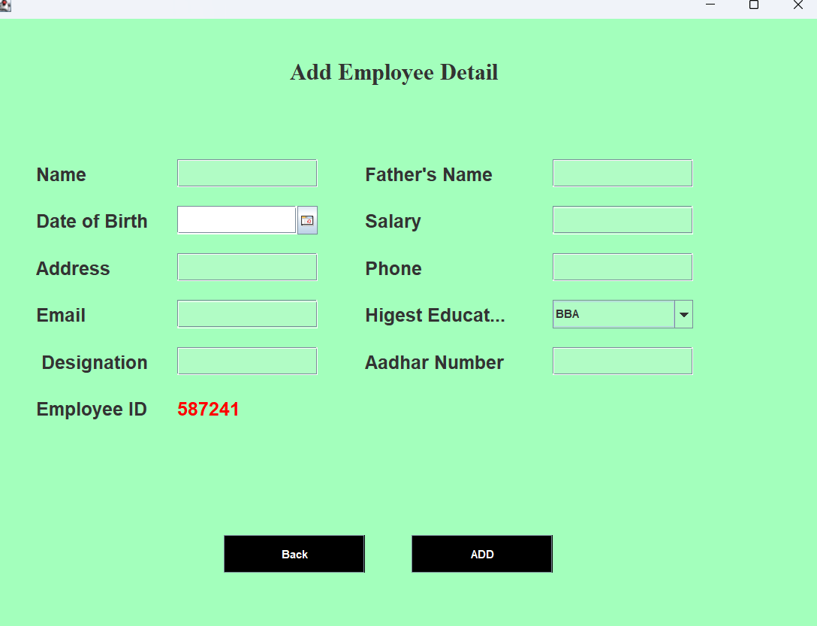
3.Add Employees Page:-

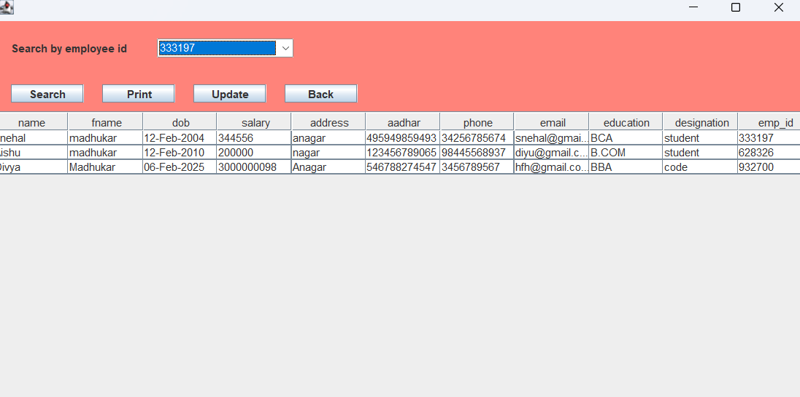
4.View Employee Page:-
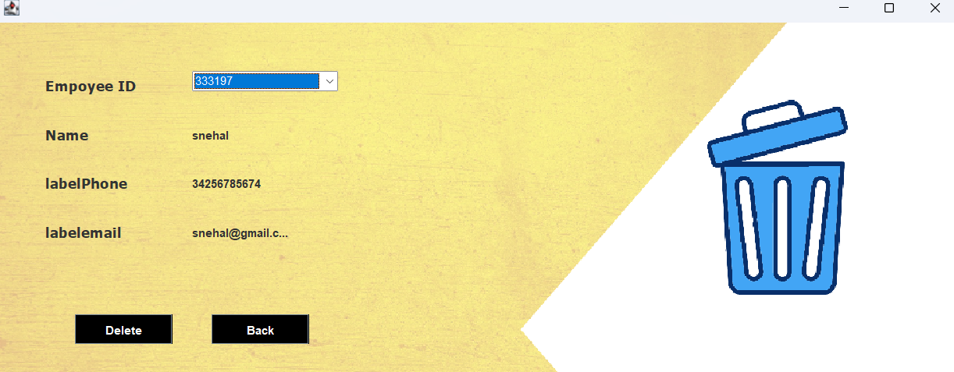
5.Remove Employee Page:-

6.Mark Attendance Page:-
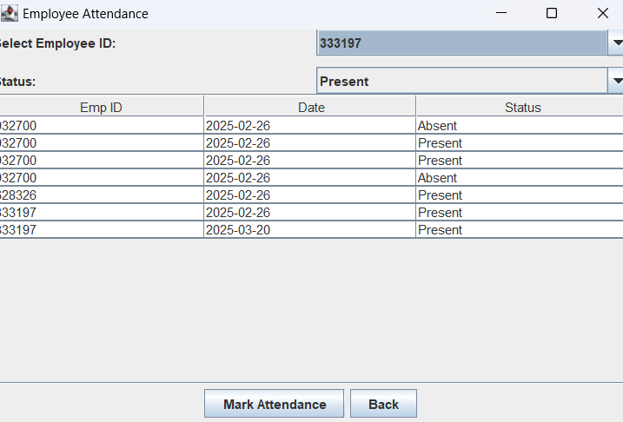

7.Monthly Attendance Report Page:-

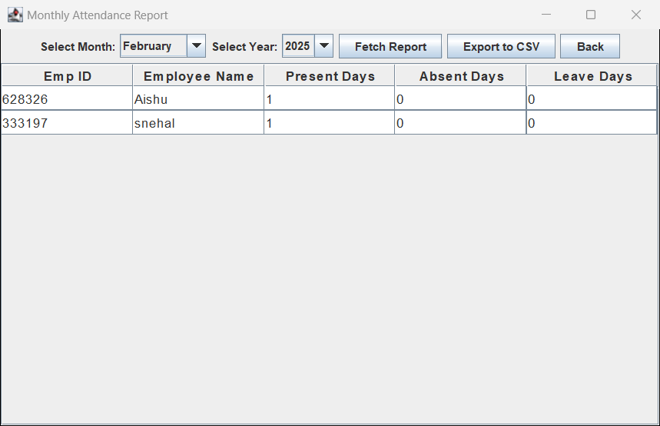

8.Update Employee Page:-

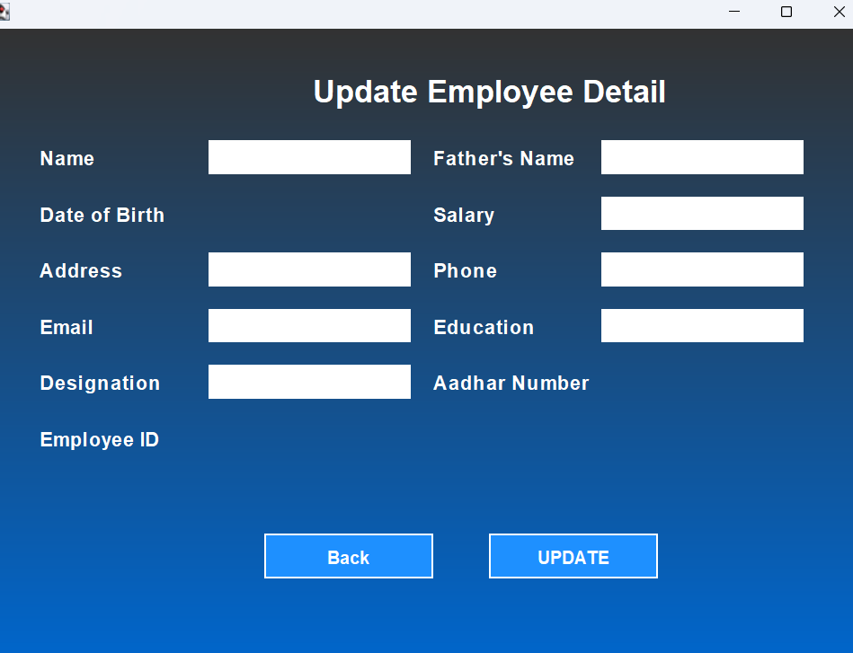

9. Project Management Page:-

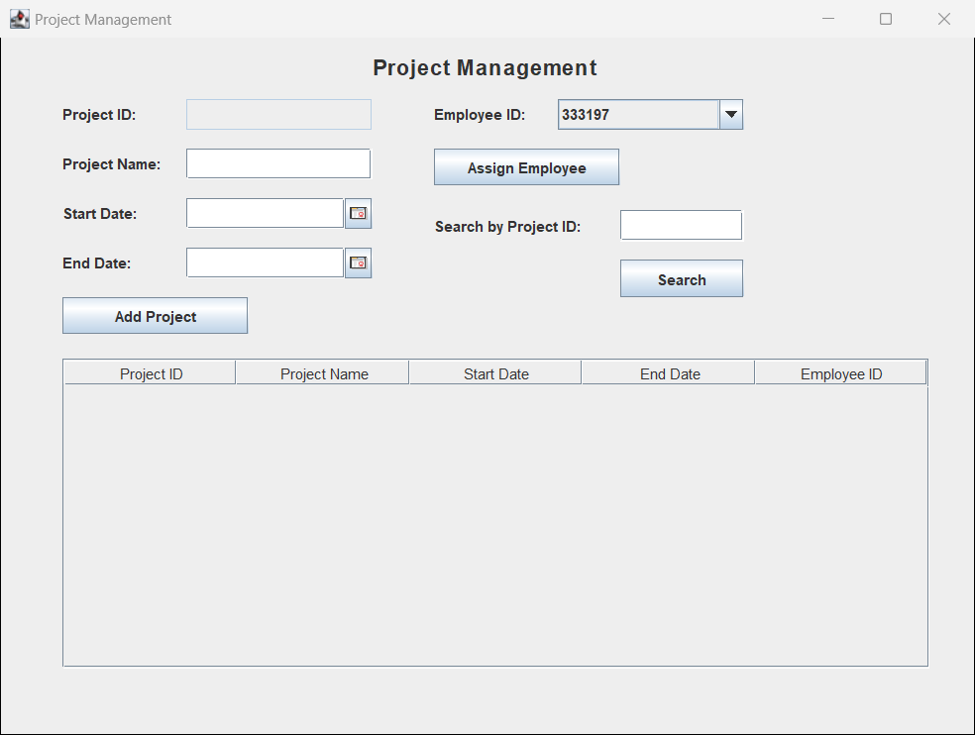

7.Limitations

- System Constraints
- Platform Dependency: The system is designed for Windows and Linux, requiring additional configurations for macOS.
- Limited User Roles: Only HR/Admin users can manage employee data; employees cannot access their own records.
- No Multi-User Access: The system does not support simultaneous updates by multiple users, leading to data conflicts.
- Functional Limitations
- No Payroll & Leave Management: The system focuses on employee records, job roles, and departments, excluding payroll and leave tracking.
- Basic Search & Filtering: Users can search by ID, name, and department, but advanced filters like skills and experience are not available.
- No Automated Reports: HR/Admin must manually retrieve and analyses data, as report generation is not automated.
3. Database & Security Constraints
- Local Storage Only: Employee data is stored in MySQL locally, with no cloud integration for remote access.
- Basic Authentication: The system uses a simple username-password login without advanced security like 2FA (Two-Factor Authentication).
- Performance Issues: Handling large datasets may slow down the system due to the lack of query optimization.
4. Future Scope
  - Implement multi-user access to prevent data conflicts.
  - Develop an employee portal for personal record access.
  - Add payroll and leave management features.
  - Integrate cloud storage for remote access.
  - Enhance security with 2FA and encrypted data storage

- Future Enhancements

The IT Company Employee Management System is designed for efficient employee data management, but future improvements will enhance its functionality, security, and accessibility.

One major enhancement will be cloud integration, allowing HR and employees to access the system remotely. This will improve data security, backup, and scalability. Additionally, multi-user support with role-based access control (RBAC) will be introduced, ensuring that employees, managers, and HR personnel have appropriate permissions.

To improve usability, advanced search filters will be added, enabling searches based on skills, experience, and project allocation. The system will also include payroll and leave management, allowing automated salary processing and leave tracking.

Performance will be optimized through database indexing, caching mechanisms, and query optimization to handle large employee datasets efficiently. Security enhancements such as two-factor authentication (2FA), data encryption, and audit logs will be implemented to protect sensitive information.

Lastly, a mobile-friendly version of the system will be developed, providing HR and employees with easy access to essential features from their smartphones. These improvements will ensure a scalable, secure, and efficient employee management system.

9.Conclusion

The IT Company Employee Management System was developed to streamline employee data management, offering efficient handling of employee records, job roles, and departmental assignments. Built using Java (Swing, AWT) with MySQL as the backend, the system ensures structured data storage, retrieval, and a user-friendly interface for HR/Admin users.

Throughout development, best practices in software design, database integration, and user interface development were followed to create a scalable and maintainable system. While the system successfully meets its core objectives, it has certain limitations, including single-user access and the absence of payroll and leave management features.

To enhance the system, future improvements will focus on cloud integration, multi-user access with role-based permissions, advanced search and reporting, and mobile application development. These enhancements will transform the system into a comprehensive HR management solution, ensuring scalability, security, and remote accessibility.

This project not only fulfills the essential needs of an IT company's HR operations but also lays the groundwork for continuous innovation in employee management technology.

10. References

During the development of the IT Company Employee Management System, various sources of information, tools, and technologies were referred to. This section acknowledges the key references that contributed to the successful implementation of the project.
- E. Balagurusamy – Programming with Java – McGraw-Hill Education.
  - Used for understanding Java programming, OOP concepts, and GUI design using Swing & AWT.
- Ramez Elmasri and Shamkant B. Navathe – Fundamentals of Database Systems – Pearson Education.
  - Provided knowledge on database design, SQL queries, and relational database management.
Online Resources & Documentation
- Oracle Java Documentation – https://docs.oracle.com/javase/
  - Referred for Java Swing, AWT, and JDBC connectivity.
- MySQL Official Documentation – https://dev.mysql.com/doc/
  - Helped in designing employee database tables and query optimization.
- GeeksforGeeks – https://www.geeksforgeeks.org/
  - Used for understanding Java GUI development, file handling, and multi-threading.
Software & Tools Used
- IntelliJ IDEA – https://www.jetbrains.com/idea/
  - Used for coding, debugging, and testing the application.
- MySQL Database Server – https://www.mysql.com/
  - Selected for secure and efficient employee data management.
Research Papers & Articles
- “Enhancing Employee Management Systems with Modern Technologies” – International Journal of Computer Applications, 2022.
  - Provided insights on automation in HR and employee data management trends.

